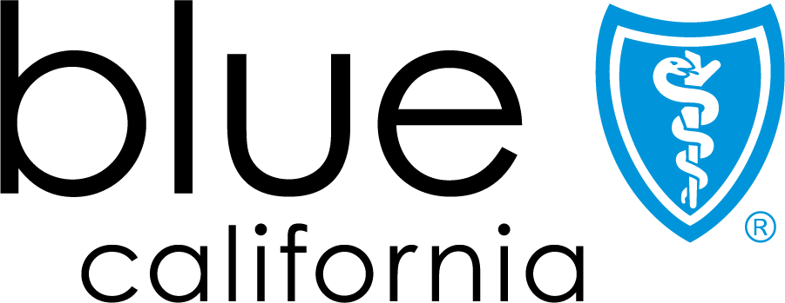

Employee Benefits
Production Release Readiness Report
Prepared by:
Ira Androphy
Senior Project Manager
Ira.androphy@ptpinc.com

July 17, 2026

Table of Contents
1.0 Introduction 3
2.0 State of Simulations 3
2.1 Simulation Results 3
2.2 User Acceptance Test Results 4
2.3 Defects 4
2.4 Residual Risks 4
3.0 Go/No-Go Recommendation 4
4.0 Cutover Plan 5
4.1 Cutover Activities 5
4.2 Hypercare Support 5
4.3 Issue Reporting & Classification 5

Hidden text: this text will not print out. There is a section break below this line. Don’t delete it. If you do accidentally delete it, strange things will happen in your document. Press Ctrl+Z on your keyboard a few times (to Undo) until it comes back. Section breaks enable us to restructure and do things to different parts of the Word page, such as portrait-to-landscape, increase the left margin and things like that.

Introduction
The Production Release Readiness Report documents the state of all critical simulations, outstanding defects, residual risks, a recommended go/no-go decision, and the July 23rd cutover plan. The Report governs the Employee Benefits PPO Medical and related Vison and Dental Specialty Plans. The steps and processes documented within the Plan guide the decision making for enabling the Employee Benefits AI Agent in Production and PTP’s subsequent hypercare support.

State of Simulations
PTP has executed 758 simulations against the Employee Benefits Agent, comprising simulations run against the PPO, Dental, and Vision Sierra knowledge based articles. The automated simulations tie to the Solutions Specifications Document (SSD) approved requirements. The SSD defines the solution in terms of behaviors that the AI Agent must perform, must not perform, should perform, or should not perform. Behaviors classified as “musts” and “nevers”, and their associated evaluations, are critical and must satisfy their associated evaluations before production release unless otherwise agreed. Behaviors classified as “shoulds”, and their associated evaluations, guide solution quality but may be deferred as agreed.

Simulation Results
The Sierra simulations executed by the Project confirmed that the Agent requirements were successfully validated. The following table summarizes the execution results of the PPO Medical PPO, Vision, and Dental simulations.
Behavior requirement | Number of Simulations | Number of Simulations Passed
Callbacks | 4 | 4
Emergency handling | 4 | 4
Grievance & Complaint | 6 | 6
Legal Disclaimers | 7 | 7
Manual Design Test | 93 | 90
Out of Domain | 19 | 19
Regression | 596 | 582
Solution Specification Document Based | 24 | 23
Survey | 5 | 5
Total Simulations | 758 | 740

This represents a 98% simulation success rate, exceeding the target pass rate of 95%.

User Acceptance Test Results
Beyond automated simulations, the Blue Shield of California teams executed thorough User Acceptance Testing (UAT) scripts against the Employee Benefit Agent. A total of 58 issues were identified, triaged, addressed, and dispositioned as shown in the table below.
Issue Category | Total | Fixed | Duplicate | Deferred
Critical | 8 | 7 | 1 | 0
Major | 23 | 17 | 4 | 2
Minor | 27 | 19 | 3 | 5
All critical issues considered as musts or never were resolved. Major and minor issues were handled in a similar fashion whereby only a small number of “should” related requirements were deferred either to backlog or to be reconsidered by the issues submitter due to misunderstood requirements or technical feasibility.
Refer to Chance Whittley email from July 9, 2026 with the Subject “BSC GA: MEM Employee UAT Results (Final QA and UAT 7/2/2026)” which includes the issue details and dispositions.

Defects
No critical or major defects remain open prior to go-live. Minor defects, reflecting “should”, will be re-evaluated, monitored, and addressed in consultation with BSC/Stellarus post go-live.

Residual Risks
All “must” and “never” requirements have been validated and do not present a current risk. There is the potential risk that the Agent responses do not align with customer expectations due to changes in requirements and preferences.

Go/No-Go Recommendation
PTP has completed pre-production activities, namely User Acceptance Test support, pre-production simulation verifications, and pre-production integration testing without incurring issues that would prevent the Employee Benefits Agent to be released to Blue Shield employees. Consequently, PTP recommends a Go for production deployment for PPO Medical, Vision, and Dental plans.

Cutover Plan
The following section describes the cutover and support processes which manage the Employee Benefits Agent production deployment and the post go-live support. Since the Agent is not yet live, the July 23rd production cutover tasks reflect the integration of Genesys and Sierra production environments so that portal to Genesys to Sierra communications are enabled.

Cutover Activities
The following tasks are completed during the production change window once the go-live decision is rendered:
Task | Responsible Party
Deploy Agent to Sierra Production Environment (release snaphot) | Ronald Marin
Set the token for the Genesys connection to Sierra Production environment | Ross Hartford
Support Stellarus/BSC Quality Assurance Integration Testing | Ross Hartford, Ronald Marin, Martha Senturia

Hypercare Support
PTP will provide hypercare support for a period of 2 business weeks following the production release of the Employee Benefits Agent. PTP will provide support during BSC business hours, Monday through Friday, with on-call engineering response for Severity 1 (Critical) incidents outside of business hours. All other severity levels are worked during business hours.

Issue Reporting & Classification
BSC will report issues through email. BSC and PTP shall jointly review submitted issues and classify each incident using the definitions below. Critical issues do not have to follow this approach when the Agent is unavailable or non-responsive.
Severity | Definition
1 - Critical | The agent is unavailable or non-responsive for all or a large subset of users; the retrieval or knowledge layer has failed; or the agent is generating harmful, false, or non-compliant outputs at scale.
2 - High | A core agent capability is significantly impaired including persistent retrieval failures, inability to complete a primary use case, or systematic hallucination on a defined topic.
3 - Medium | Agent behavior is degraded in a limited or non-core way, including inconsistent grounding or stale knowledge content, and a workaround exists or the issue occurs only under specific conditions.
4 - Low | Minor issue, knowledge base content correction, prompt or instruction adjustment, or non-urgent refinement of an existing agent behavior.

The response commitments are outlined in the following table and PTP will make reasonable efforts based on root cause, complexity, and dependency on third-party platforms:
Severity | Initial Response | Working Commitment | Status Updates
1 - Critical | Within 1 business hour | Continuous engineering effort until the issue is resolved or a stable workaround is in place | Every 2 hours
2 - High | Within 4 business hours | Engineering effort during business hours, not paused while the issue is open | Daily
3 - Medium | Within 1 business day | Triaged into the hypercare backlog and worked during business hours based on impact | Daily
4 - Low | Within 3 business days | Logged, prioritized, and addressed within the Hypercare Period or transferred to a post-hypercare backlog as agreed | Weekly

